Challenge 2: The second challenge gave us some background information and asked us to find the key to gain access to a secret party.

Some dude I know is planning a party at some bar in New York! I really want to go but he's really strict about who gets let in to the party. I managed to find this packet capture of when the dude registered the party but I don't know what else to do. Do you think there's any way you can find out the secret password to get into the party for me? By the way, my favorite hockey player ever is mario lemieux.

First thing to do is filter the protocol list to see if there is any protocols that can contain password data.

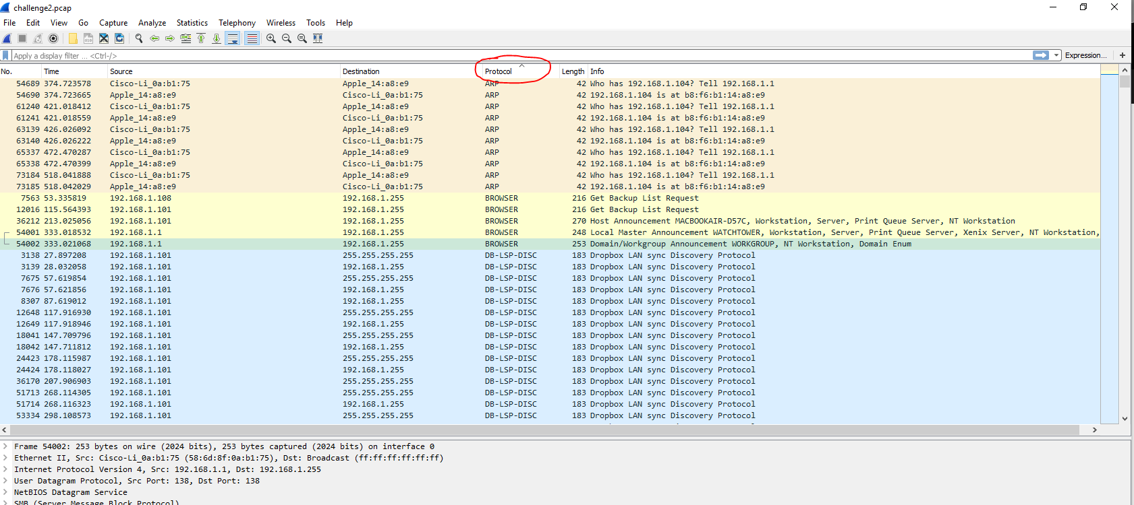

There was no protocol that stood out straight away and needed to be analysed more. Because we don’t know what we are looking for, so for ease of use I have decided to use Network Miner to display the details used in more readable data. To do this we need to convert the file to be read on the free network miner from pcapng to a standard pcap file.

While searching through the file I was unable to find the credentials for the secret password, but what I did find was the cookie a website called members.brewersassociation which could be related to the login area.

